# Lab 2 – Simple Programs

Problem 1. How Much Spaghetti Sauce?

A spaghetti sauce recipe calls for the following ingredients:

2 cups of tomato sauce

1/3 cup of tomato paste (.333)

2 cloves garlic

1 tablespoon oregano

The recipe produces 4 servings with this amount of ingredients. Write a program that asks the user how many servings they want to make, then displays the amount of each ingredient needed for the specified number of servings.

**Design.** You will be using an IPO diagram to design your program. See IPO diagram attached to this assignment. Under INPUTS, list everything the program will need to produce the result. Under OUTPUTS, list what the program is going to produce. Under the PROCESS heading, list the detailed pseudocode steps that need to occur to produce the program’s output. This includes formulas your program will need. See sections 2.1 and 2.2 on designing a program and using pseudocode.

**Code.** Write your program in Python using the above steps. Save your program as a .py file with the name *yourlastname*_Lab2.1.py

**Output.** Your program should produce correctly labeled output rounded to 2 decimal places. See section 2.8 More About Output. Sample dialog:

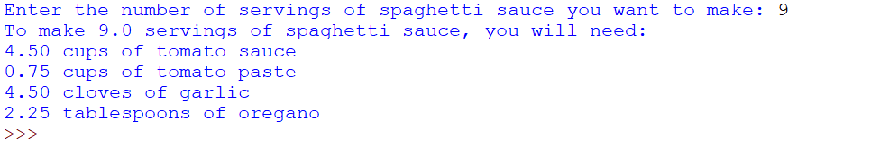**Programming Style Requirements.**

Comments – Begin your program with a comment that includes: a) your name, b)program status – either “Complete” or describe any incomplete or non-functioning part of your program c)A 1-3 line description of what the program does.

Variable names – use meaningful variable names such as total_taxes or num_cookies.

Named constants – Use named constants for all number values that will not be changed in the program such as RECIPE_TOMATO_SAUCE = 2.0. See section 2.9 on Named Constants

You will have two files to turn in to Blackboard. One .py files and one IPO chart. Attach all files before pressing SUBMIT.